##### **Long/Short Global Macro Strategies with Target Beta Using the 3-Factor Model**

##### **Theo Dimitrasopoulos*, Yuki Homma\***

* Department of Financial Engineering; Stevens Institute of Technology Babbio School of Business

**Abstract**

In this project we construct a Long/Short Global Macro Strategy based on French Fama 3-Factor Model with a Target Beta and evaluate its sensitivity to variation of Beta and its sensitivity to the length of the estimation for covariance matrix and the expected returns under different market scenario. Several comparisons are drawn between different target betas as well as different term structures.

**Theories**

French Fama 3-Factor Model

Historically, French Fama 3-Factor Model is regarded as a development of CAPM which explains a relationship between expected returns and risk factors. Sharpe, Lintner, and Black developed an asset pricing model referred as CAPM which illustrates expected returns on the securities are a positive linear function of market beta. The CAPM, developed theoretically, had an empirical success, and became the standard model for describing the cross-sectional structure of expected returns on equity. However, some researchers revealed there were some anomalies that cannot be explained by the CAPM. Banz found the market equity had a relationship between expected returns. Stocks with smaller market equity had higher rates of return, usually referred to as the small cap effect. Bhandari found leverage helps explain the cross-section of average stock returns. Stattman, Rosenberg, Reid and Lanstein found that average returns on U.S stocks were positively related to the ratio of a firm’s book value of common equity to its market value.

In response to this criticism, Eugene Farmer, and Kenneth French, in a paper published in 1992, empirically showed that the four representative anomaly factors discovered at the time in the U.S. stock market: market equity, book-to-market ratio, leverage, and E/P (the inverse of P/E ratio), were aggregated into market equity and book-to-market ratio.

They advanced their study and proposed French Fama 3-factor model which describes a cross section of average stock returns with three factors, market risk premium, market equity, and book-to-market ratio.

Under the Farmer-French 3-factor model, the random return of security is given by the following formula

$$\begin{aligned}\begin{aligned}r_{i}-r_{f}=α_{i}+β_{i}^{MKT}\left(r_{m}-r_{f}\right)+β_{i}^{SMB}r_{i}^{SMB}+β_{i}^{HML}r_{i}^{HML}+ϵ_{i}\#\end{aligned}\#\left(1\right)\end{aligned}$$

With $E\left[ϵ_{i}\right]=0$, $E\left[r_{i}\right]=R_{i}$, $E\left[r_{m}\right]=R_{m}$, $E\left[r_{i}^{SMB}\right]=R_{SMB}$, $E\left[r_{i}^{HML}\right]=R_{HML}$, expected return on a security can be written as

$$\begin{aligned}R_{i}-r_{f}=α_{i}+β_{i}^{MKT}\left(R_{M}-r_{f}\right)+β_{i}^{SMB}R_{SMB}+β_{i}^{HML}R_{HML}\#\left(2\right)\end{aligned}$$

Where $r_{i}$ is a random return on a security, $r_{f}$ is a risk-free rate, $r_{M}$ is a market return, and three $βs$, $β_{i}^{MKT}$, $β_{i}^{SMB}$, $β_{i}^{HML}$ is a sensitivity measure for risk premium of market portfolio, risk factor of market equity, and risk factor of book-to-market ratio, respectively.

Markowitz Portfolio THeory

Markowitz portfolio theory also known as modern portfolio theory is a theory on how risk-averse investors can construct portfolio to maximize expected return based on a given level of market risk. The theory can also be used to construct a portfolio that minimize risk for a given level of expected return. In mathematical format:

$$\begin{aligned}\min_{ω}{ω^{T}Σω} \#\left(3\right)\end{aligned}$$

Subject to

$$\begin{aligned}e^{T}ω=1 \#\left(4\right)\end{aligned}$$

$$ρ^{T}ω=ρ_{T}$$

Where $ω$ is a vector of weights of securities, $Σ$ is a covariance matrix , $ρ$ is an expected return, $ρ_{T}$ is a target return.

Linear regression

An approach for predicting a quantitative response Y n the basis of multiple predictor variable $X_{j}$ that assume an approximately linear relationship between $X_{j}$ and Y. For a model with p predictors, the linear regression takes the form

$$\begin{aligned}Y=β_{0}+\sum_{j=1}^{p}{β_{j}X_{j}}+ε \#\left(5\right)\end{aligned}$$

with $X_{j}$ is the $j$ th predictor and $β_{j}$ qualifies the relationship between that predictor and the response. Given estimates for $β's$, it can make predictors using the model

$$\begin{aligned}\hat{f}\left(X\right)= {\hat{β}}_{0}+\sum_{j=1}^{p}{\hat{β_{j}}X_{j}} \#\left(6\right)\end{aligned}$$

where we estimate these parameters by minimizing the residual sum of squares

$$\begin{aligned}RSS={\sum_{i=1}^{n}{(y_{i}-}{\hat{β}}_{0}-\sum_{j=1}^{p}{\hat{β_{j}}X_{j}})}^{2} \#\left(7\right)\end{aligned}$$

**Investment Universe and Backtesting**

Data

We used following 12 ETFs from March 1st 2007 to June 30th 2020:

1. CurrencyShares Euro Trust (FXE)
2. iShares MSCI Japan Index (EWJ)
3. SPDR GOLD Trust (GLD)
4. Powershares NASDAQ-100 Trust (QQQ)
5. SPDR S&P 500 (SPY)
6. iShares Lehman Short Treasury Bond (SHV)
7. PowerShares DB Agriculture Fund (DBA)
8. United States Oil Fund LP (USO)
9. SPDR S&P Biontech (XBI)
10. iShares S&P Latin America 40 Index (ILF)
11. iShares MSCI Pacific ex-Japan Index Fund (EPP)
12. SPDR DJ Euro Stoxx 50 (FEZ)

We chose S&P 500 (SPY) as the benchmark we considered.

The data for constructing French Fama 3-Factor Model is quoted from Ken French’s website for the factors’ historical values.

ANALYSIS PERIOD

Divided entire analysis period into 5 sub-periods:

1. Pre-Subprime Crisis : March 22, 2007 – March 3, 2008
2. During Subprime Crisis : March 3, 2008 – September 10, 2010
3. Post-Subprime Crisis : September 10, 2010 – January1, 2015
4. Pre-Covid19 Pandemic : January 1, 2015 – March 9, 2020
5. During Covid19 Pandemic : March 9, 2020 – October 30, 2020

BACKTESTING

Individual backtests were executed for each sub-period to compare strategies. We compared with different perspectives.

1. Impact on Beta Target

Compared our strategy in terms of target beta in the same sub-period. Changed target beta $β_{T}^{m}$,and compare performance.

1. Impact of various term structure given Beta

Compare portfolios’ performance with different term structures and fixed beta. $S_{j}^{i}$ represents a term structure with $i$ days lookback period to estimate the expected return and $j$ days lookback period to estimate the covariance matrix.

We also ran a backtest on whole period from March 1st, 2007 to November 30th, 2020.

**Investment Strategy**

OBJECTIVE FUNCTION

We considered the following investment strategy:

$$\begin{aligned}\max_{ω}{ρ^{T}ω-λ{\left(ω-ω_{p}\right)}^{T}Σ\left(ω-ω_{p}\right)} \#\left(8\right)\end{aligned}$$

With constraints

$$\begin{aligned}\sum_{i=1}^{n}{β_{i}^{m}ω_{i}=β_{T}^{m}} \#\left(9\right)\end{aligned}$$

$$\sum_{i=1}^{n}{ω_{i}=1}$$

where

* $ω_{i}$: weight allocated to each security $S_{i}$, and $ω$ is a vector of weights.
* $ρ$: a vector of expected returns of security $S_{i}$
* $Σ$: the covariance matrix between securities returns derived from the Factor model
* $ω_{p}$: composition of a reference Portfolio, the previous portfolio when rebalancing the portfolio.
* $λ$: small regularization parameter to limit turnover.
* $β_{i}^{m}=\frac{cov(r_{i},r_{M})}{σ^{2}\left(r_{M}\right)}$: the Beta of security $S_{i}$ defined in the CAPM model.
* $β_{T}^{m}$: the Portfolio’s Target Beta

TERM STRUCTURES

We analyzed the following combinations of term structures and Target Beta

$S_{60}^{60}$

$S_{120}^{60}$

$S_{60}^{90}$

$S_{120}^{90}$

$S_{60}^{120}$

$S_{120}^{120}$

TARGET BETA

$β_{T}^{m}=\{-1.0, -0.5, 0.5, 1.0, 1.5, 2.0\}$

Performance and Risk metrics

We introduced following metrics to compare portfolio’s performance and a degree of risks. We assumed that each year has 250 trading days to annualize these metrics.

PERFORMANCE METRICS

* Cumulated Return
* Annual Arithmetic Mean / Geometric Mean Return
* Annual Min Return
* Max 10-days Drawdown
* Sharpe Ratio

RISK METRICS

* Volatility
* Daily VaR
* Annual VaR
* Modified VaR
* Annual CVaR
* Skewness
* Kurtosis

**Results & Discussion**

1. The evolution the graph of cumulated daily Profit and Loss as summing that investing $100 at the first allocation date

**Pre-Subprime Crisis**

Figure 1: the evolution of cumulated daily profit and loss for several portfolio strategies (Pre-Subprime Crisis)

D**uring Subprime crisis**

Figure 2: the evolution of cumulated daily profit and loss for several portfolio strategies (During Subprime Crisis)

**Pos-Subprime crisis**

Figure 3: the evolution of cumulated daily profit and loss for several portfolio strategies (Post-Subprime Crisis)

1. The distribution of daily returns

The following plots shows the distribution of daily returns for different term structures and $βs$.

**Pre-Subprime**

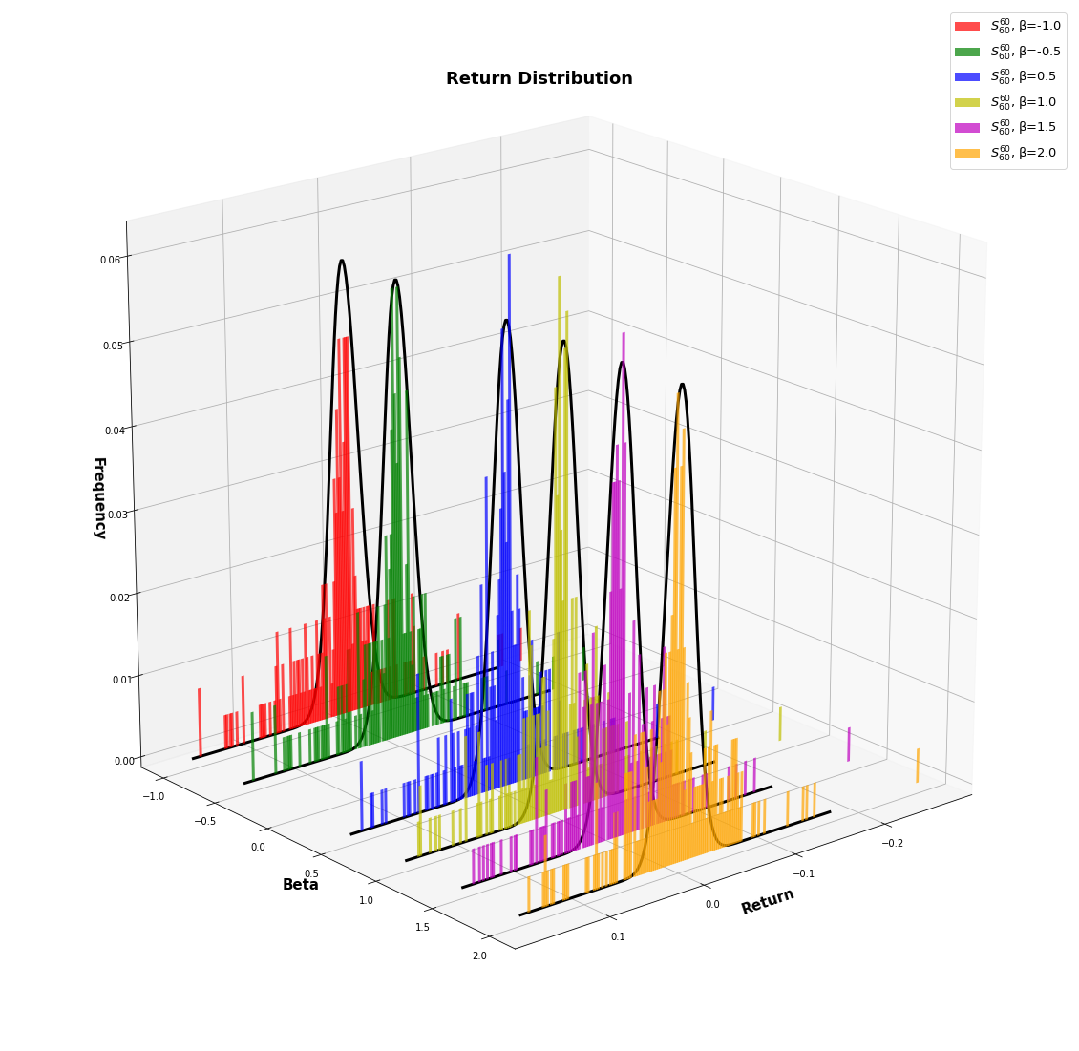

Figure 2: Distribution of daily returns of $S_{120}^{60}$

Figure 3: Distribution of daily returns of

Figure 4: Distribution of daily returns of $S_{60}^{90}$

Figure 5: Distribution of daily returns of

Figure 7: Distribution of daily returns of $S_{120}^{120}$

Figure 6: Distribution of daily returns of $S_{60}^{120}$

**During Subprime Crisis**

Figure 8: Distribution of daily returns of

Figure 9: Distribution of daily returns of

Figure 10: Distribution of daily returns of

Figure 11: Distribution of daily returns of

Figure 13: Distribution of daily returns of $S_{120}^{120}$

Figure 12: Distribution of daily returns of $S_{120}^{90}$

Post-Subprime Crisis

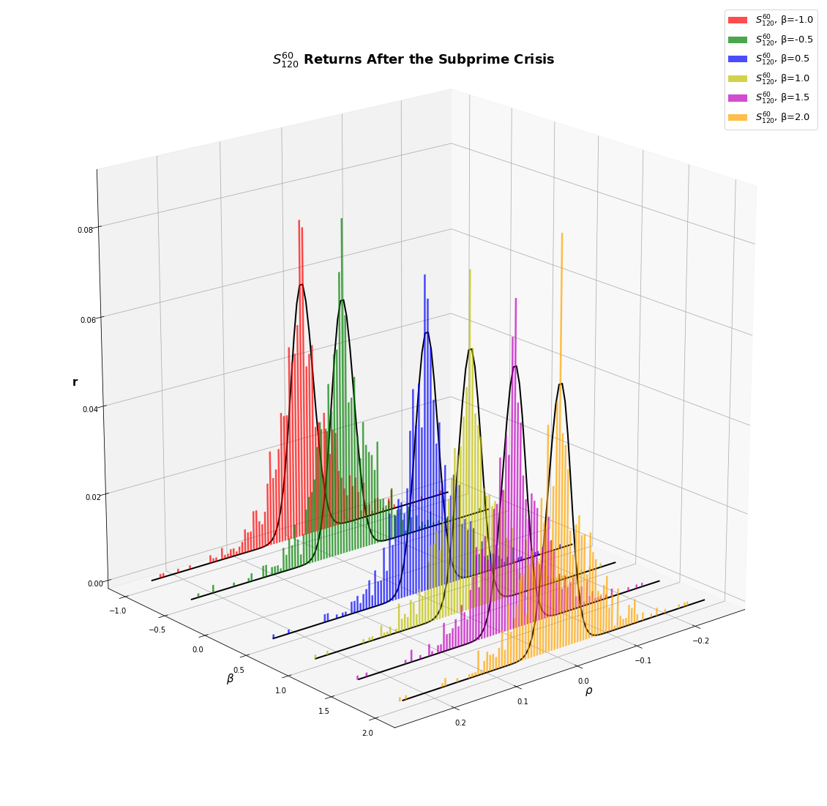

Figure 8: Distribution of daily returns of

Figure 9: Distribution of daily returns of

Figure 10: Distribution of daily returns of

Figure 11: Distribution of daily returns of

Figure 13: Distribution of daily returns of $S_{120}^{120}$

Figure 12: Distribution of daily returns of $S_{120}^{90}$

1. Comparison of Strategies’ Performances and Risks
2. Pre-Subprime Period













References

1. Eugene F. Fama, Kenneth R. French, “The Cross-Section of Expected Stock Return” ,The Journal of Finance, vol. 47, No.2 , 1992, pp. 427–465.
2. Eugene F. Fama, Kenneth R. French, “Common risk factors in the returns on stocks and bonds” ,Journal of Financial Economics, vol. 33, No.1 , 1993, pp. 3–56.
3. Eugene F. Fama, Kenneth R. French, “Size and Book-to-Market Factors in Earnings and Return” ,The Journal of Finance, vol. 50, No.1 , 1995, pp. 131–155.
4. Eugene F. Fama, Kenneth R. French, “Multifactor Explanation of Asset Pricing Anomalies” ,The Journal of Finance, vol. 51, No.1 , 1996, pp. 55–84.
5. Francis, Kim, “Modern Portfolio Thoery”, Wiley Finance

Authors

**Theo Dimitrasopoulos** – MSc. Financial Engineering, Stevens Institute of Technology 2021, Bachelor of Science in Engineering, Structural Engineering, Princeton University 2017; tdimitr1(at)stevens(dot)edu

**Yuki Homma** – MSc. Financial Engineering, Stevens Institute of Technology 2021, Bachelor of Science, Physics, Keio University 2019; yhomma(at)stevens(dot)edu